CS 3050 Homework # 2. Name :Hamza Thabit

Submitted to Blackboard, due at 11:59pm on Feb. 26, 2019.

1. Give an efficient algorithm in pseudo code to reverse a singly linked list of n
elements. The algorithm should use no more than constant storage beyond that
needed for the list itself.

Listold(head and tail)
Listnew list (head and tail)
Do{

Listnew insert at head (listold (head))
Oldlist move head

}while(node->next != NULL)

Insert at head{
Takes a node
Sets the node.next to current head
Sets head to node
}

2. Given a Hash function f(x) = x² for 1000 integers in the range of –1000 to 1000, list 2 problems that could arise. Suggest a better Hash function to resolve these problems.

Expenential memory allocation
All signed numbers when squared become ‘+’ causing cullisions and an empty bottom half of array.

F(x)= log2(x)
Solves both problems and populates evenly

3. Demonstrate what happens when we insert the keys 3, 11, 80, 74, 92, 1024, 32, 59, 503, 293, 2010, 22, 104 into a Hash table with collisions resolved by chaining. Let the table have 11 slots, and let the Hash function be h(k) = k mod 11.

3, 11, 80, 74, 92, 1024, 32, 59, 503, 293, 2010, 22, 104
3, 0 , 3 , 8 ,4 , 1 , 10, 4 , 8 , 7 , 8 ,0 , 5

0 | 1 | 2 | 3 | 4 | 5 | 6 | 7 | 8 | 9 | 10
11 | 1024 |  | 3 | 59 | 104 |  | 293 | 503 |  | 32
22 |  |  | 80 | 92 |  |  |  | 2010

4. Consider a Hash table of size m = 128 and a corresponding Hash function h(k) = floor( m (kA mod 1) ) for A = (sqrt(5)-1)/2. Compute the locations to which the keys 1000, 1001, 1002, 1003, and 1004 are mapped.

Number | 1000 | 1001 | 1002 | 1003 | 1004
position | 4 | 83 | 34 | 113 | 64

5. Suppose the open address hash table T has m = 13 slots and the hash function used is h(k, i) = (h1(k) + i · h2(k)) mod 13, where
• h1(k) = k mod 13 and
• h2(k) = 1 + (k mod 11)
Assuming we start from an empty Hash table, insert the numbers 31, 41, 5, 9, 26, 54 into the Hash using open addressing. Please follow the order and write one number at a time in each line under the following table to the right position:

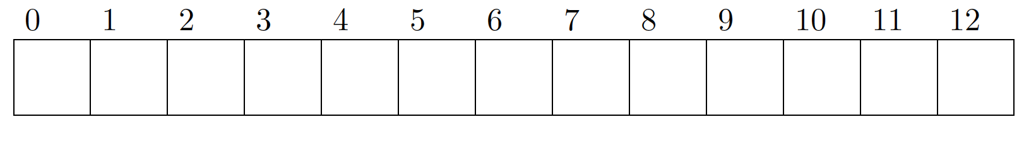

h(31,0)= 31 mod 13 +0 = 5
h(41,0)= 41 mod 13 +0 = 2
h(5,1)= 5 mod 13 +1(5 mod 11) = 10
h(9,0)= 9 mod 13 +0 = 9
h(26,0)= 26 mod 13 +0 = 0
h(54,0)= (54 mod 13) + 1(54 mod 11)= 12

0 | 1 | 2 | 3 | 4 | 5 | 6 | 7 | 8 | 9 | 10 | 11 | 12
26 |  | 41 |  |  | 31 |  |  |  | 9 | 5 |  | 54

